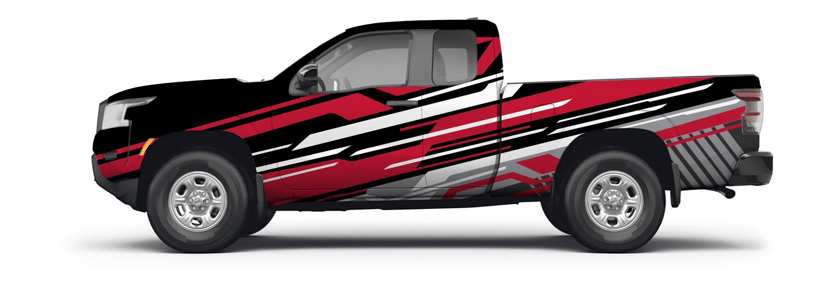

Here is a rendering of my truck that I have selected to recreate as a 3D scene. This vehicle does consist of multiple objects including wheels, tires, truck bed, and the front end. These objects are a great option to create into 3D because any vehicle needs an exact circle (or in this case a cylinder) to drive properly. If I were to use another object as an example, let us say a round bush, that bush doesn't have to be perfectly round whereas wheels do. So, the primitive shapes that will be used to create 3D representations of the 2D object are cylinder, torus, cube, and plane.

First, the plane will represent the ground for the objects’ reference point. Then, there will be four toruses to represent the tires. What will fit right inside the toruses are four cylinders to represent the wheels. Next, there will be two cubes to represent the truck bed. Then, there will be a total of four cubes to represent the front end. Three will be next to each other and one on top of the last one. However, the first cube of the row of 3 will be slightly smaller than the others to show the narrower front that turns to the middle part of the vehicle’s body.